Heberle, Gregory William
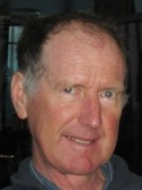
Born 22.7.1947 Katanning WA. Educated Katanning, Lockyer, Spencer Park (Albany) Primary Schools and Albany High School to Dec 1964. Bachelor of Science in Forestry from University of W.A./ Australian National University Canberra, graduated 1968. In 1965-66 resided in St Georges College, Crawley, in 1967-68 at Garran Hall, Canberra. Assistant Divisional Forester with Forests Dept at Manjimup 1968-69 (administration and inventory), Harvey 1970-76 (inventory & planning), Manjimup 1976-80 (district manager), Bunbury 1980-83 (regional planner), Manjimup 1983-87 (acting regional manager). Department name changed to Dept of Conservation and Land Management (CALM) in 1985. With CALM at Bunbury 1987-90 (departmental forest planner), Perth 1990-2001 (economics, forest resource planner, forest auditor). Fished with family professional fishing business at Doubtful Is Bay in March each year (annual leave) 1965-66, 1969-2002. Lived in Bunbury 1987-90; Nollamara 1990-99; Craigie 1999-2006, with partner Wendy Poynton, 1999-2004. Lived in South Yunderup 2006 -, in house on canal. Retired from CALM 28.6.2001. Defacto marriage 1982-92, to Cheryl Yvette Head, who changed name to Heberle. Children: Tania, Stacey, Brian.
Has self published 6 family history books, distributed free to family members. Which can be accessed by the links:
BOOK by Greg Heberle (2005) "Heberle family 1500-2005" 204 pages, 500 printed | 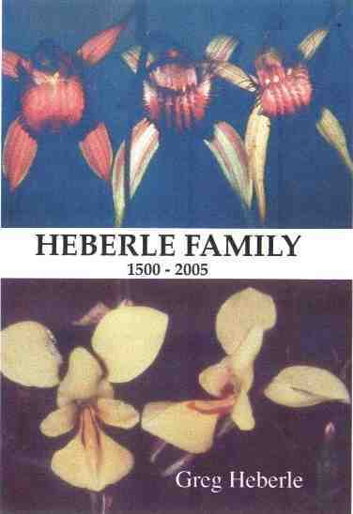
BOOK by Greg Heberle (2006) "Heberle fishing, Western Australia 1929-2004" 120 pages, 400 printed, | 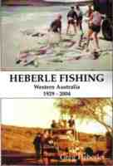
BOOK by Greg Heberle et al (2006) "Ron Heberle orchid photos, Western Australia" 88 pages, 400 printed | 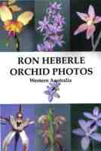
BOOK by Greg Heberle (2006) "Heberle in Australia 1851-2006" 60 pages, 200 printed | 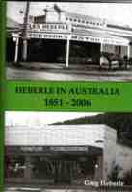
BOOK by Greg Heberle (2007) "Descendants of Graham from Eyre and Narrogin Western Australia 1877-2007"227 pages, 700 printed | 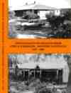
BOOK by Greg Heberle (2008) "Heberle with ancestors from Clausthal-Zellerfeld c1580-2008"116 pages, 100 printed | 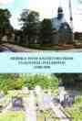
Main webpage – Homepage, which has links to >40 other webpages, including:
HEBERLE FISHING
THYLACINES IN WEST AUSTRALIA alleged sightings of the extinct Tasmanian Tiger
ALBANY HIGH SCHOOL, WEST AUSTRALIA, year IV 1963, year V 1964
St GEORGES COLLEGE, CRAWLEY, WEST AUSTRALIA, 1965-1966
AUSTRALIAN FORESTRY SCHOOL 1926-1964
AUSTRALIAN NATIONAL UNIVERSITY (ANU) SCHOOL OF FORESTRY
FOREST FIELD OFFICERS, FORESTRY REUNIONS, WEST AUSTRALIA
WHALING STATIONS DOUBTFUL ISLAND BAY, WEST AUSTRALIA - First Whaling Station in WA (1836)
West Australian HEBERLE FAMILY and relations CRUISES
DOUBTFUL ISLAND BAY, West Australia, where Heberle fished
RON HEBERLE ORCHIDS photos of >850 West Australian native orchids taken by Ron L Heberle. Papers by Ron L. Heberle

